Be not afraid!

You have nothing to fear! God would not found a religion to give it bad teachings that would make you unhappy!

You have objections against some teachings of the Church, for example on abortion, or Papal infallibility, or homosexuality, or Transubstantiation? Don't worry: there are wise and solid answers to all your objections!

And if ever the true Church of God had moral requirements that were stricter than those you currently live by, that wouldn't be a problem! Don't forget we're talking about Christianity, with Jesus the good shepherd who seeks out the lost sheep [Mt 18:14]. Christianity is the religion with a God Who is meek and humble of heart, rich in mercy, and who invites all those who toil under a heavy burden to come to Him, to find rest [Mt 11:29].

To contact us

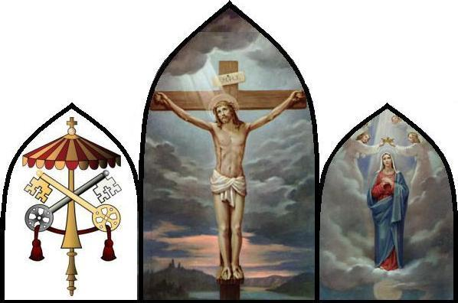

www.jesus-eucharistie.org

www.inquisition.ca

Stefan Jetchick
1450, av. des Grands-Pins
Québec, QC
G1S 4J6
Canada
(418) 922-7015

Ecclesiastical Permission

Our request to the Quebec Diocese for the Imprimatur was made in 2005-June-11.
No response has yet been given.

Version: 2017-March-29

And If It Were True?

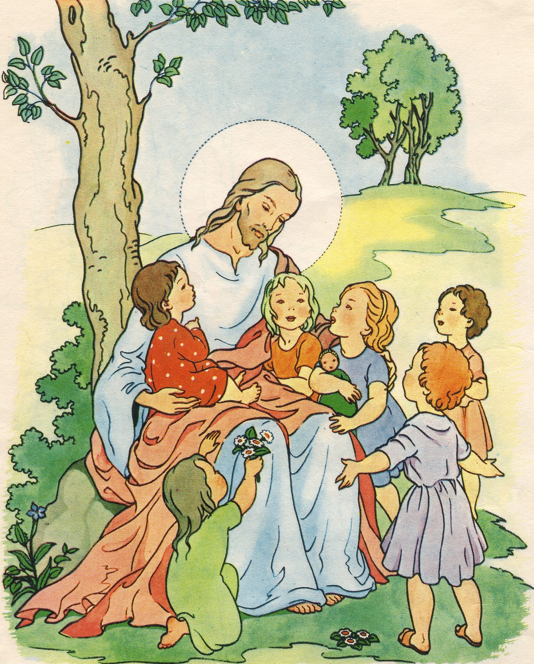

"For God so loved the world that he gave his only Son, so that everyone who believes in him might not perish but might have eternal life." [John 3:16]

Catholicism?

The prevalent anti-Catholicism

All day long, whether in the newspapers, on the radio or TV, we're harassed with all kinds of insinuations like:

"God doesn't exist!"

or

"Jesus Christ isn't God!"

or

"Jesus Christ didn't found the Catholic Church!"

or

"The Catholic Church has corrupted the message of Jesus Christ !"

etc., etc. ...

But is this true? Did you take a bit of time to examine those insinuations?

Reliable witnesses

When a judge wants to know whether an accused is guilty or not, will he listen to hearsay and slander? No! He'll listen to serious and reliable witnesses. You must do the same thing for Catholicism. Here is a first reliable witness:

And here is a second reliable witness:

www.vatican.va
Choosing life and happiness

The Catholic Church is the salt of the earth and, currently, this salt has lost much of its flavor here in Quebec, which explains why the "Culture of Death" is causing so much destruction in our society.

Physically, French-Canadians are self-exterminating with abortion, suicide, the pill, divorce, euthanasia, unmarried cohabitation, the legal glorification of acts against nature, etc.

Mentally, we could also say French-Canadians are trying to commit suicide, by "entertaining" themselves to death. Whether it's with TV, or drugs, or shopping malls, or noisy "music", or alcohol, several persons try to forget that without God, we are "Organic pain-collectors racing toward oblivion".

